### **2214 HI 1454 SEC1060 DATA SCIENCE IN HI**

**Final Project Report**

***Link to our presentation slides:***

[FINAL_PRESENTATION.pptx](https://1drv.ms/p/s!Ai03sXU176rg_DACYh82P_fNQqrC?e=JcmwID)

1. **Explore the NOAA website and give a brief description of the website and what information is contained on the site https://www.ncdc.noaa.gov/cag/global/mapping (DENISE)**

The NOAA website provides a nationally updated and regulated resource of data on short and long-term atmospheric temperature, and ocean temperature, breaking them up by intervals of months. The “Time Series” tab allows the user to choose from drop-down menus of the timescale (months), the start month, the start year, the end year, location, and surface type. The location selection can be broken down into continent, hemisphere, latitude, and longitude. The surface type drop-down contains land, ocean, or land and ocean. The website then displays a bar plot and a chart both can be downloaded. The “Rankings” tab outlines the record weather, it is organized on a table in increasing weather intervals, the next column displays anomalies or outlier temperatures, with rankings of how relatively they rank among the recorded statistics. The user can choose to which degree of heat or coolness is ranked. Lastly, the NOAA website links to educational material about climate and climate change monitoring on the National Centers for Environmental Information website.

1. **Also provide a brief history of NOAA and what it does. How is the work of NOAA beneficial, not just to the USA, but, to the world as a whole? (ALERTA)**

* **HISTORY: NOAA’s roots reach back more than 200 years**

In 1807, President Thomas Jefferson founded the U.S. Coast and Geodetic Survey (as the Survey of the Coast) to provide nautical charts to the maritime community for safe passage into American ports and along our extensive coastline. The Weather Bureau was founded in 1870 and, one year later, the U.S. Commission of Fish and Fisheries was founded. Individually, these organizations were America’s first physical science agency, America’s first agency dedicated specifically to the atmospheric sciences and America first agency dedicated specifically to the atmospheric sciences, and America’s first conservation agency. The cultures of scientific accuracy and precision, service to protect life and property, and stewardship of resources of these three (Explore National Weather Service history, Explore NOAA Fisheries history, Explore the history of Coast Survey) agencies were brought together in 1970 with the establishment of NOAA, an agency within the Department of Commerce (NOAA.).

* **HOW is the work beneficial, not just to the USA, but, to the world as a whole?**

NOAA is an agency that enriches life through science. Our reach goes from the surface of the sun to depths of the ocean floor as we work to keep the public informed of the changing environment around them. From daily weather forecasts, severe storm warnings, and climate monitoring to fisheries management, coastal restoration and supporting marine commerce, NOAA’s products and services support economic vitality and affect more than one-third of America’s gross domestic product. NOAA’s dedicated scientists use cutting-edge research and high-tech instrumentation to provide citizens, planners, emergency managers and other decision makers with reliable information they need, when they need it. NOAA’s mission to better understand our natural world and help protect its precious resources extends beyond national borders to monitor global weather and climate, and work with partners around the world. Their agency holds key leadership roles in shaping international ocean, fisheries, climate, space and weather policies. NOAA's many assets – including research programs, vessels, satellites, science centers, laboratories and a vast pool of distinguished scientists and experts – are essential, internationally recognized resources. They work closely with other nations to advance our ability to predict and respond to changes in climate and other environmental challenges that imperil Earth’s natural resources, human life and economic vitality (NOAA.).

With the U.S. experiencing increasingly frequent and severe extreme weather, water, ocean, and climate events, such as flooding, wildfires, drought, and heat waves, low-income communities and communities of color are often disproportionately impacted by these disasters. Many Alaska Natuve villages are facing imminent existential threats from coastline flooding, erosion, and melting permafrost. Wildfires in California and other western states threaten the lives, properties, and livelihoods of residents and businesses, and the associated smoke negatively affects vulnerable agricultural and other outdoor workers. Record-breaking heat across the country is linked to increased risk of illness and death for at-risk groups such as older adults, people with asthma, and outdoor workers. Worsening heat waves are creating deadly “heat islands,” predominantly in lower income urban communities of color, where these neighborhoods can be up to 20°F hotter than surrounding areas. NOAA is responding to these and other environmental injustices by developing new and enhanced climate products and services to meet the needs of our most vulnerable communities. To achieve this goal begins internally by accelerating our commitment to diversity, equity, inclusion and accessibility so that the organization looks more like America and everyone shares a strong sense of belonging. Externally, they are undertaking listening sessions across the country to better understand community needs and to design more equitable, accessible climate solutions. They are also assessing several of our key climate programs to identify and address barriers facing underserved communities to more effectively tackle their climate challenges and enhance economic development. Finally, NOAA has created a new NOAA Climate Council to leverage and coordinate our resources and expertise, and those of our partners, to enhance the equitable delivery of climate science and services. These environmental justice resources are tailored to address a wide range of climate challenges and solutions to help underserved communities prepare for, respond to and build back better from climate-induced disasters.

Science at NOAA is the systematic study of the structure and behavior of the ocean, atmosphere, and related ecosystems; integration of research and analysis; observations and monitoring; and environmental modeling. NOAA science includes discoveries and ever new understanding of the ocean and atmosphere, and the application of this understanding to such issues as the causes and consequences of climate change, the physical dynamics of high-impact weather events, the dynamic of complex ecosystems and biodiversity and the ability to model and predict the future states of theses systems. Science provides the foundation and future promise of the service and stewardship elements of NOAA’s mission.

Service is the communication of NOAA’s research, data, information and knowledge for use by the Nation’s business, communities and people’s daily lives. NOAA services include climate predictions and projections; weather and water reports, forecasts and warnings; nautical charts and navigational information; and the continuous delivery of a range of Earth observations and scientific data sets for use by public, private and academic sectors. Stewardship is NOAA’s direct use of its knowledge to protect people and the environment, as the Agency exercises its direct authority to regulate and sustain marine fisheries and their ecosystems, protect endangered marine and anadromous species, protect and restore habitats and ecosystems, conserve marine sanctuaries and other protected places, respond to environmental emergencies and aid in disaster recovery. The foundation of NOAA’s long-standing record of scientific, technical and organizational excellence is its people. NOAA’s diverse functions require an equally diverse set of skills and constantly evolving abilities in its workforce. Also underlying NOAA’s continued success is its unique infrastructure. NOAA’s core mission functions require satellite systems, ships, buoys, aircraft, research facilities, high-performance computing and information management and distribution systems. The agency provides research-to-application capabilities that can recognize and apply significant new understanding to questions, develop research products and methods and apply emerging science and technology to user needs. NOAA invests in and depends heavily on the science, management and engagement capabilities of its partners. Collectively, NOAA’s organizational enterprise-wide capabilities – its people, infrastructure, research and partnerships – are essential for NOAA to achieve its vision, mission and long-term goals (NOAA.).

Earth’s ecosystems support people, communities and economies. Our own human health, prosperity and well-being depend upon the health and resilience of natural and social ecosystems. Managing this interdependence requires timely and usable scientific information to make decisions. Human well-being requires preparing for and responding to changes within these natural systems. NOAA’s mission of science, service and stewardship is directed to a vision of the future where societies and their ecosystems are healthy and resilient in the face of sudden or prolonged change. A vision of resilience will guide NOAA and its partners in a collective effort to reduce the vulnerability of communities and ecological systems in the short-term, while helping society avoid or adapt to potential long-term environmental, social and economic changes. To achieve this vision they must understand current Earth system conditions, project future changes and help people make informed decisions that reduce their vulnerability to environmental hazards and stresses that emerge over time, while at the same time increase their ability to cope with them. Resilient human communities and economies maintain or improve their health and vitality over time by anticipating, absorbing, diffusing and adapting to change. Resilient communities and institutions derive goods from ecosystems in a way that does not compromise ecosystem integrity, yet is economically feasible and socially just for future generations. Climate, weather, and water affect all life on our ocean planet. NOAA’s mission is to understand and predict our changing environment, from the deep sea to outer space, and to manage and conserve America’s coastal and marine resources (NOAA.).

1. From the NOAA site pick a City and State, Time Scale of 1-Month, Month: pick a month (Tell us why you picked that city and month), Start Year of 1970 and End Year2021 (Remember to click Plot before downloading the data) (DENISA)

The city of Baton Rouge is the capital of Louisiana. Baton Rouge is rich with over 300 years of history, nicknamed the “Red Stick City” by French explorers, boasts an amazing landscape sitting on the Mississippi River, and is rich with Cajun and Creole culture. The Battle of Baton Rouge is the only battle of the American Revolution fought outside the original thirteen colonies. On Sept. 21, 1779, the army fought the Battle of Baton Rouge for three hours, until the British surrendered. The site of a Spanish battery near the Louisiana State Capitol can now be visited. The weather during the month of May on average is 74 degrees Fahrenheit and is predicted to be 76.27 degrees in May of 2022. The month of May also boasts peak season for crayfish. Crayfish are small freshwater crustaceans that resemble miniature lobsters. Crayfish season is from November until July, with peak season in the spring months including May. Louisiana-style crayfish is cooked in a large pot of seasonings alongside spices and aromatics like garlic, onions, oranges, and peppers. Add-ons such as corn, potatoes, and ​​andouille sausage can be added alongside as balanced pairings to the spicy and fragrant crayfish. The phenomenal weather alongside the timing for crayfish season provides a great reason to visit the city of Baton Rouge during the month of May. This timing also avoids the harsh summer heat, although visitors can still enjoy the warm weather.

1. **Tell us about the weather in the City and State that you chose 15 points (LaLa)**

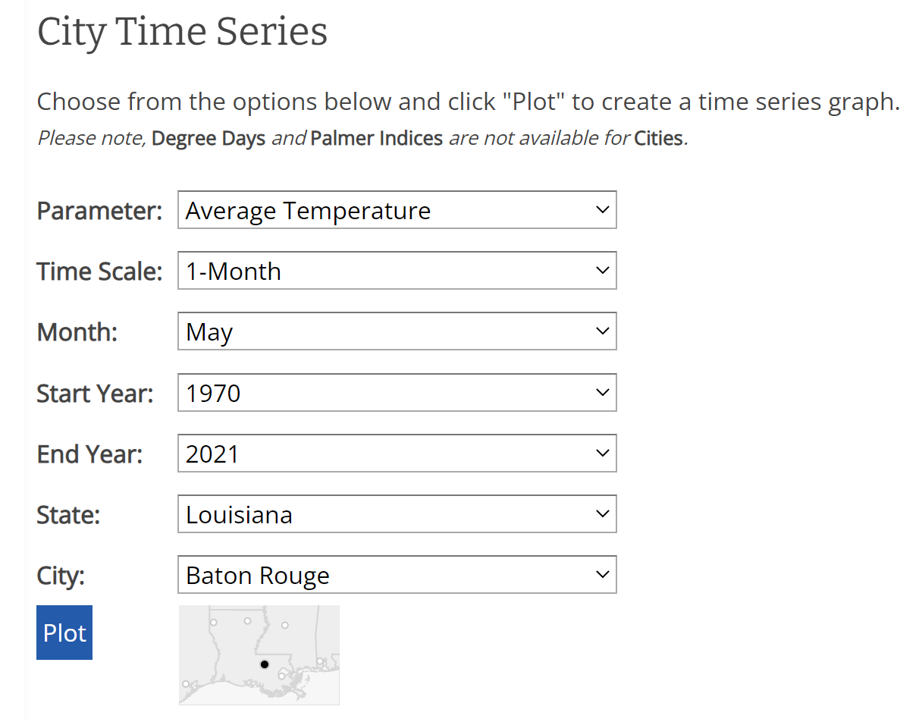

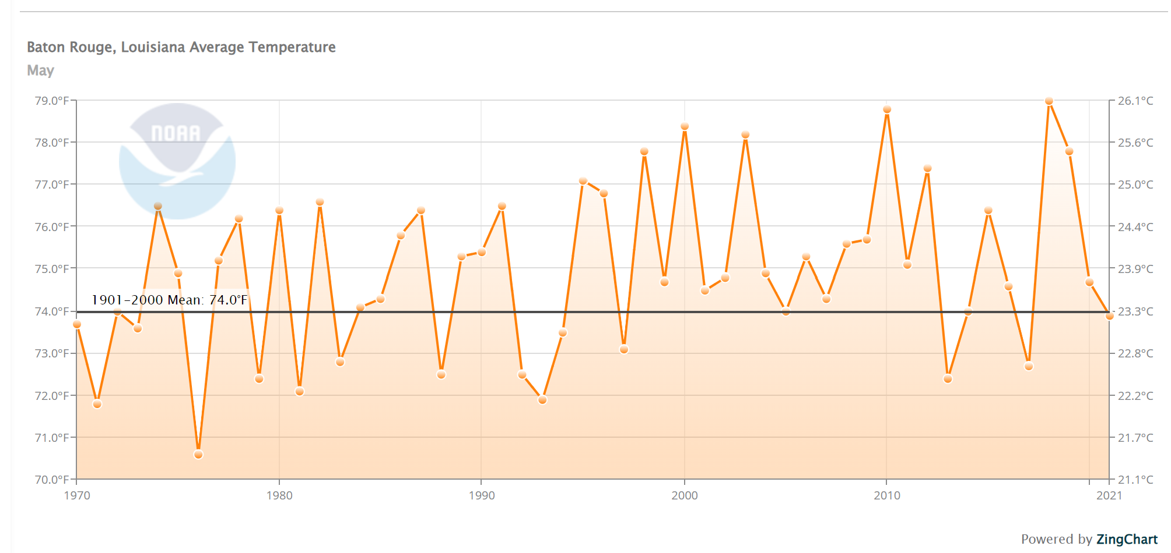

The weather in the capital city, Baton Rouge, LA has a mean of 74.0 degrees Fahrenheit or 23.3 degrees Celsius in May. Here, Baton Rouge has the lowest weather temperature at 70.0 degrees Fahrenheit or 21.1 degrees Celsius and the highest weather temperature at 79.0 degrees Fahrenheit or 26.1 degrees Celsius. As it is shown, the highest weather temperature at Baton Rouge in May consistently increased each year from 1970 until 2021.

1. **Download the data to your computer (Elizabeth).**
   1. The file will be downloaded with some metadata on the top
   2. Right click, edit and delete the metadata so you have a file that looks like the file below

Date, Value, Anomaly

189501,34.2,-3.2

189601,34.7,-2.7

189701,35.5,-1.9

189801,39.6,2.2

20 points

1. 1. **Use pandas to load the data you downloaded from NOAA (Elizabeth).**

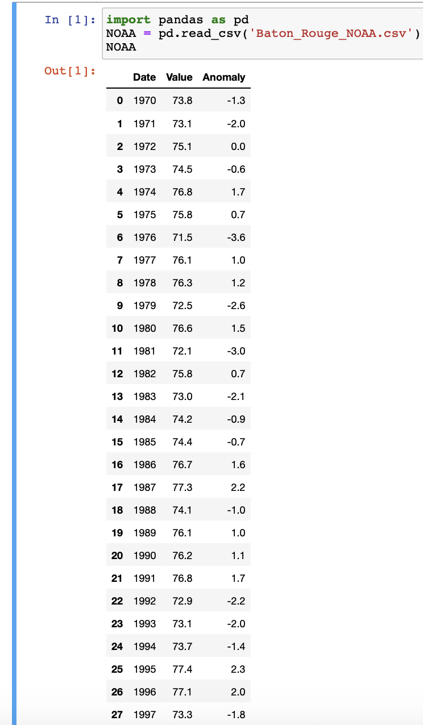

* 1. **Display the head of the data (Elizabeth).**

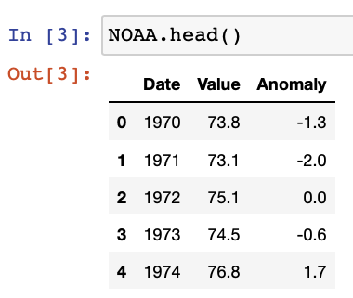

* 1. **Display the tail of the data (Elizabeth).**

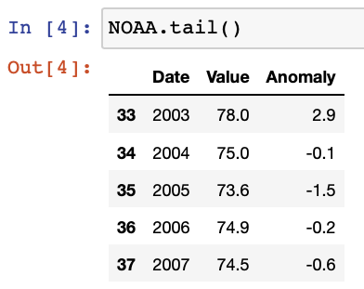

* 1. **Set the precision of all the data points to 2 (Elizabeth).**

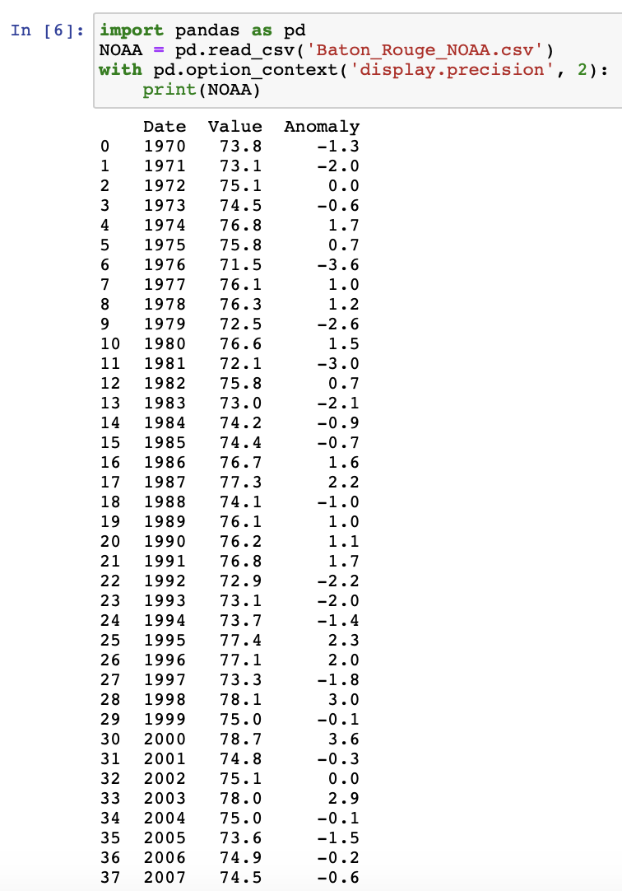

* 1. **Cleanup the data so that the columns will display Date, Temperature and Anomaly as the column names (Elizabeth).**

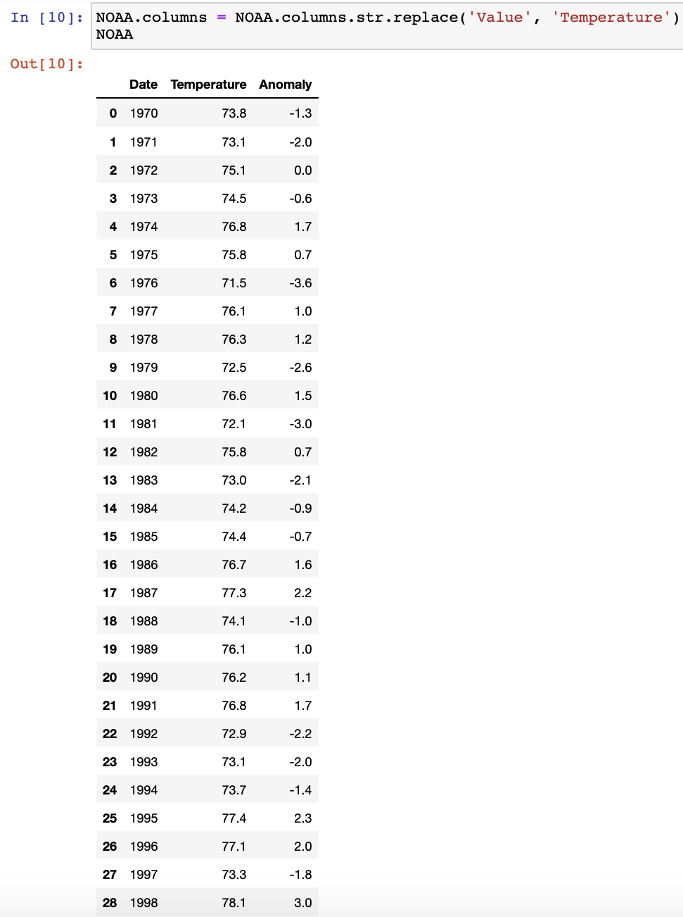

* 1. **Display the first 30 data points (Elizabeth).**

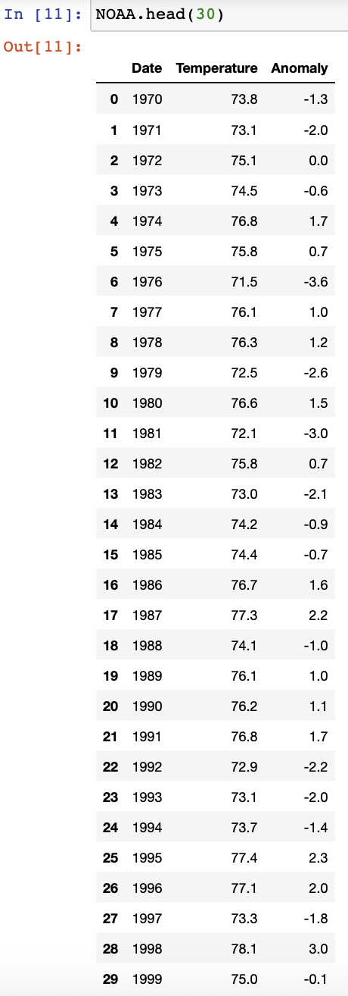

* 1. **Get the descriptive statistics and explain what each of them mean (remember to mention your state, city month etc. in your discussion). Be precise!!! 25 points(Elizabeth & Bowen)**

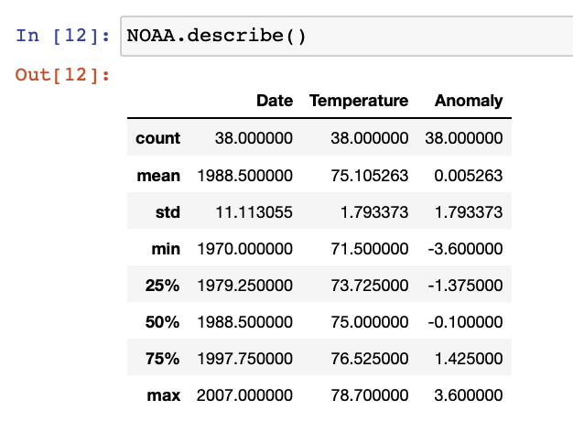

We have a total of 38 data points, and the mean of the NOAA data set is 75.1 Fahrenheit which is standard compared to the average temperature in Baton Rouge, Louisiana which is equal to 74 degrees Fahrenheit in the month of May. The standard deviation is low means that most of the data are clustered together. The 25%,50%,75% stands for the quartiles which are normally distributed. The lower quartile ends at 25% and pretty close to the median which is 50% and the upper quartile ends at 76 and that is even closer to the mean. Over all the median lies on the slightly right side of the normal distribution.

1. **Perform linear regression analysis of your data (Elizabeth)**

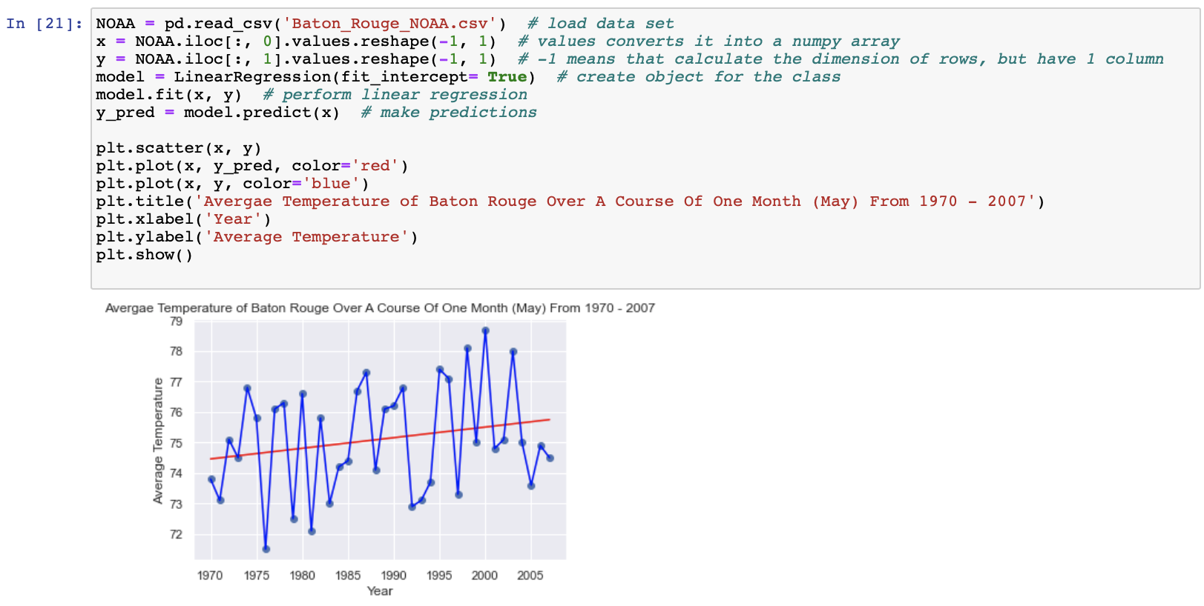

1. **Interpret your results (Bowen)**

The linear line is positive, although output is a low R-squared value, it indicates that our independent variable is not explaining much in the variation of our dependent variable - regardless of the variable significance, this is letting us know that the identified independent variable, even though significant, is not accounting for much of the mean of our dependent variable it may also mean that the prediction could be way off the actual temperature, but it shows an overall positive trend (temperature increase).

1. **Display the parameters of the regression and explain what they mean (Elizabeth & Bowen)**

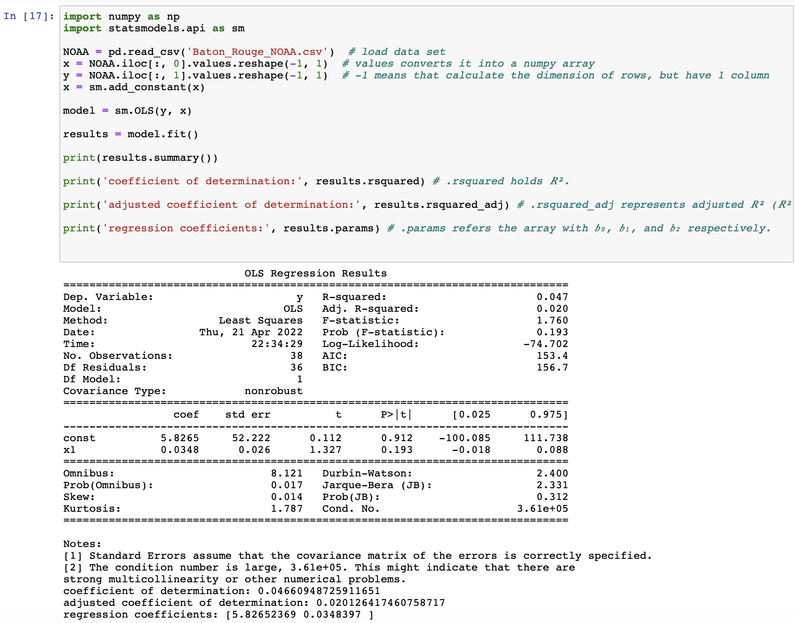

So, in this result, we used a package that can generate the overall regression results for us. The p-value is very high in our regression result which may indicate that our evidence is not strong enough to suggest an effect exists in the population. An effect might exist but it’s possible that the effect size is too small, the sample size is too small, or there is too much variability for the hypothesis test to detect it.

1. **Use your regression model to forecast the temperature in 2022 (Bowen)**

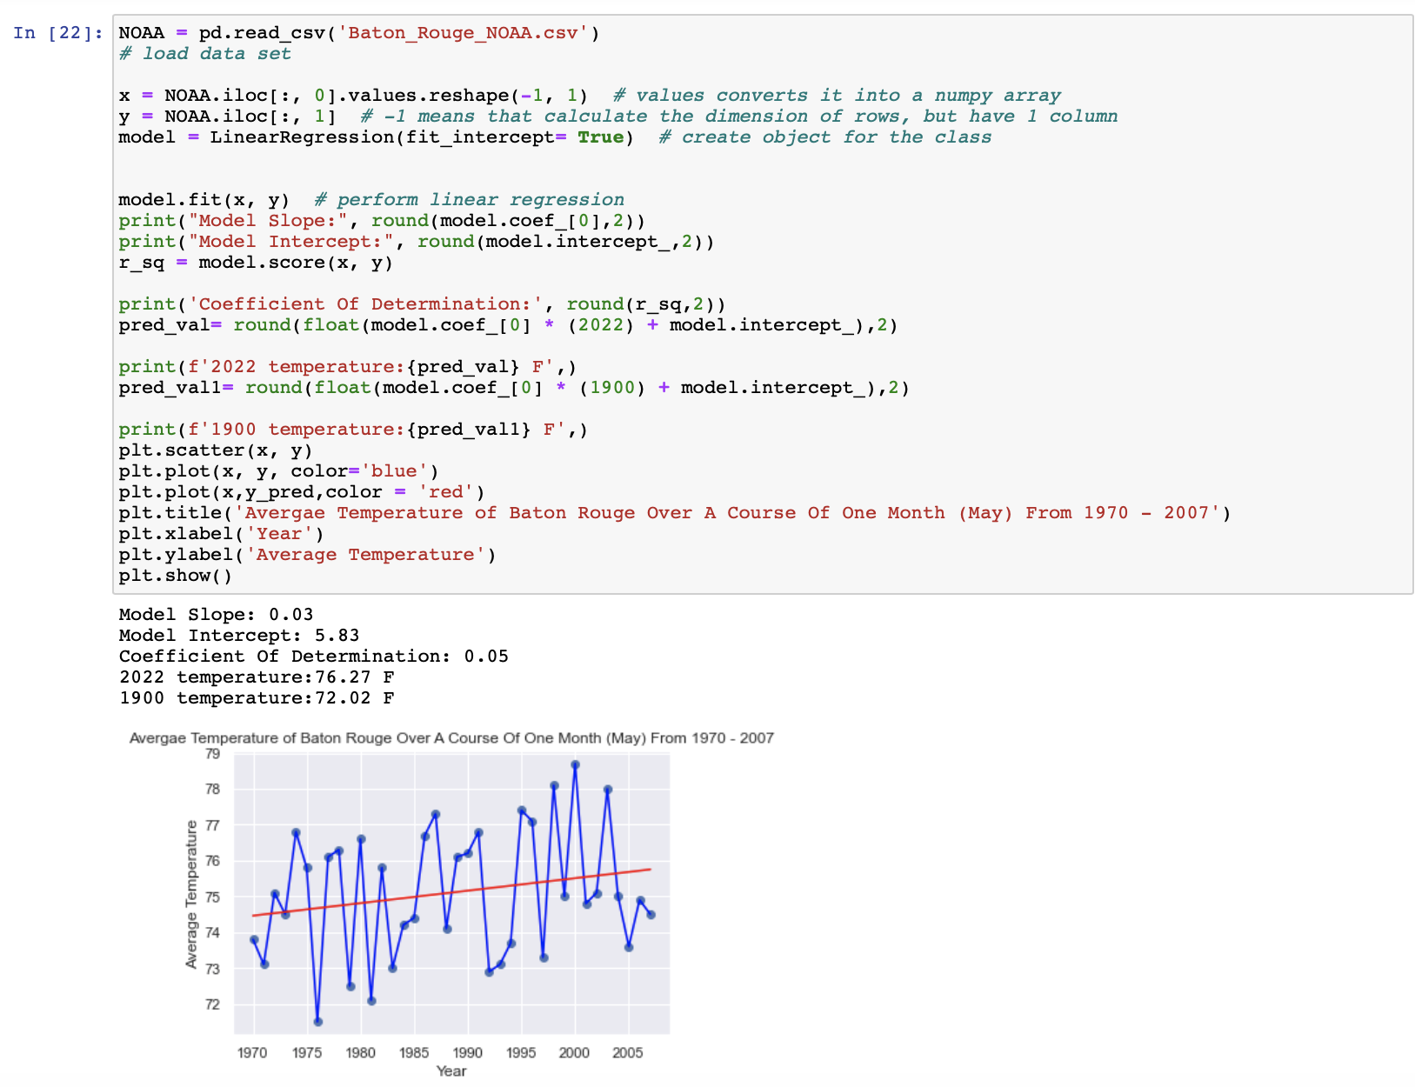

In May 2022, the temperature at Baton Rouge, Louisiana is predicted to be 76.27 degrees Fahrenheit.

1. **Also use the model to predict what the temperature was in 1900 (Bowen)**



In May 1900, the temperature at Baton Rouge, Louisiana was predicted to be 72.02 Fahrenheit.

1. **Conclusion (DenisA & LaLa)**

From the NOAA website, our group decided to choose the dataset from the city of Baton Rouge in Louisiana in the month of May within the year range of 1970 - 2021. The weather in the capital city, Baton Rouge, LA has a mean of 74.0 degrees Fahrenheit, with the lowest temperature of 70.0 degrees Fahrenheit and the highest weather temperature at 79.0 degrees Fahrenheit. According to the graph attached, the temperature at Baton Rouge in the month of May consistently increased each year from 1970 until 2021. Based on the descriptive statistics output, we have a total of 38 data points and the mean of 75.1 degrees Fahrenheit. And, we have a low standard deviation which means that most of the data are being clustered together. Overall, the median lies on the slightly right side of the normal distribution.

In the linear regression analysis, the linear is positive even if the R-square is quite low, indicating that the forecast could be well off the actual temperature, but that the temperature growth is on a generally positive trend in the overall analysis. The p-value is extremely high, which means that the equation will not be able to accurately forecast the temperature. The Omnibus test also reveals that the regression is not relevant in this case as well.

Through the regression model to forecast the temperature in May, 2022, the temperature at Baton Rouge, Louisiana is predicted to be 76.27 degrees Fahrenheit. But, it is predicted to be 72.02 degrees Fahrenheit in May, 1900. However, based on the World Weather statistical analysis, the average weather at Baton Rouge, Louisiana in May 2021, is 79 degrees Fahrenheit during the day and 69 degrees Fahrenheit at night.

Life in Louisiana will only get wetter, hotter and more humid in the coming decades, according to the latest international warning on climate change. And the extreme weather will be more than just uncomfortable - it will be deadly and already is. The report, dubbed “a damning indictment of failed climate leadership” by a top United Nation official, examined how people, especially those in coastal communities like in Louisiana, are already suffering from the effect of an increase in global temperature of 1.1 degree Celsius, or about 2 degrees Fahrenheit. The inability to curb greenhouse gas emissions has ensured the world will warm by at least 1.5 degrees Celsius, or 3 degrees Fahrenheit, come 2050, and those effects are locked in (Parker, H.). It also necessitates action at all levels on wider issues that undermine a community’s ability to withstand disasters, such as racial divisions and the state’s high poverty rate, which leave residents without the resources to deal with disasters on their own.

Peer Review: 15 points

Important!! Make sure to cite your references

**Works Cited**

NOAA. (2022, April 6). *Our history | National Oceanic and Atmospheric Administration*. Our History NOAA’s Roots Reach Back More than 200 Years. [https://www.noaa.gov/heritage/our-history#:%7E:text=NOAA’s%20roots%20reach%20back%20more%20than%20200%20years&text=In%201807%2C%20President%20Thomas%20Jefferson,and%20along%20our%20extensive%20coastline](https://www.noaa.gov/heritage/our-history#:%7E:text=NOAA%E2%80%99s%20roots%20reach%20back%20more%20than%20200%20years&text=In%201807%2C%20President%20Thomas%20Jefferson,and%20along%20our%20extensive%20coastline)

NOAA. (2017, December 17). *About our agency | National Oceanic and Atmospheric Administration*. About Our Agency. <https://www.noaa.gov/about-our-agency>

NOAA. (2022a, March 11). *Our mission and vision | National Oceanic and Atmospheric Administration*. Our Mission and Vision Science, Service and Stewardship. <https://www.noaa.gov/our-mission-and-vision>

NOAA. (2021, September 29). *NOAA’s Role in Environmental Justice | National Oceanic and Atmospheric Administration*. NOAA’s Role in Environmental Justice. <https://www.noaa.gov/environmental-justice/noaas-role-in-environmental-justice>

Parker, H. (2022, March 3). *Climate change could prove more deadly in Louisiana without immediate action, report says*. WWNO. <https://www.wwno.org/coastal-desk/2022-03-03/climate-change-could-prove-more-deadly-in-louisiana-without-immediate-action-report-says>

NOAA National Centers for Environmental information, Climate at a Glance: City Time Series, published April 2022, retrieved on April 21, 2022 from <https://www.ncei.noaa.gov/access/monitoring/climate-at-a-glance/>

World Weather. (n.d.). *Weather in Baton Rouge in May 2021 (Louisiana) - detailed Weather Forecast for a month*. World-Weather.Info. <https://world-weather.info/forecast/usa/baton_rouge/may-2021/>